Cloud Control Remote Upgrades

As of ZVR 6.0, Zerto added the ability to remotely upgrade the ZVMs from the Zerto SaaS platform. If you and your customers are on **ZVR 6.0 or higher**, then you will be able to leverage the Upgrade Manager of the myZerto.com Cloud Control section.

Requirements: The ZVM must have “Enable Zerto SaaS Features” enabled under the “About” section of Zerto site settings and the ZVM must have port 443 open to <https://zerto-mobile-data.zerto.com>:

http://s3.amazonaws.com/zertodownload_docs/Latest/Zerto%20Virtual%20Replication%20Zerto%20Virtual%20Manager%20%28ZVM%29%20-%20vSphere%20Online%20Help/AdministratorforZertoVirtualManager/images/About_Cloud.png

Remote Upgrade Process:

1. Log into the myZerto.com and navigate to the Cloud Control tab:

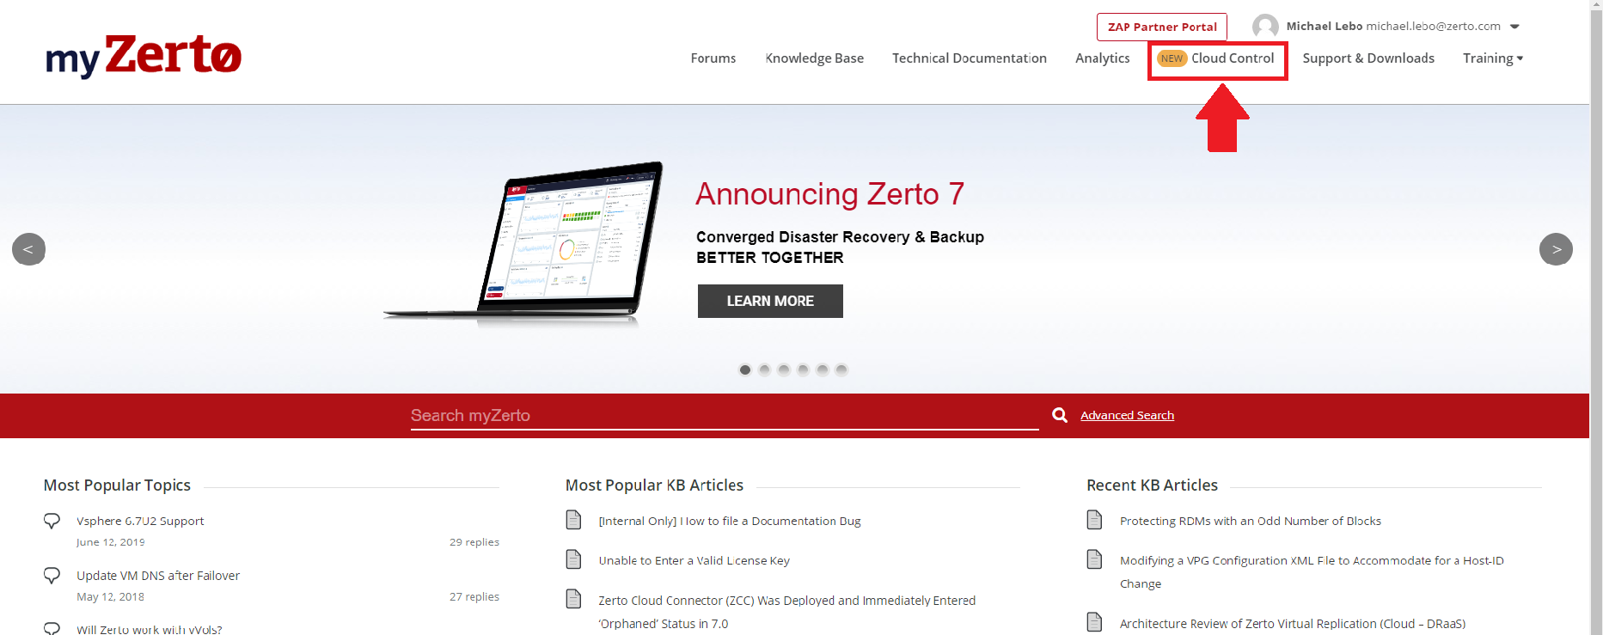

1. Under the Cloud Control section, navigate to the Upgrade Manager tab. The ZVM sites within the Upgrade Manager will only be ZVMs leveraging your account’s licensure. This will include all your ZVMs and any customer ZVMs. The Upgrade Manager will also provide basic information about the ZVMs, including the current version, site-to-site pairing, ZORG name, and more. Select the site that you would like to upgrade by checking the box to the left of the ZORG name, and then selecting the “Remote Upgrade” option on the top left:

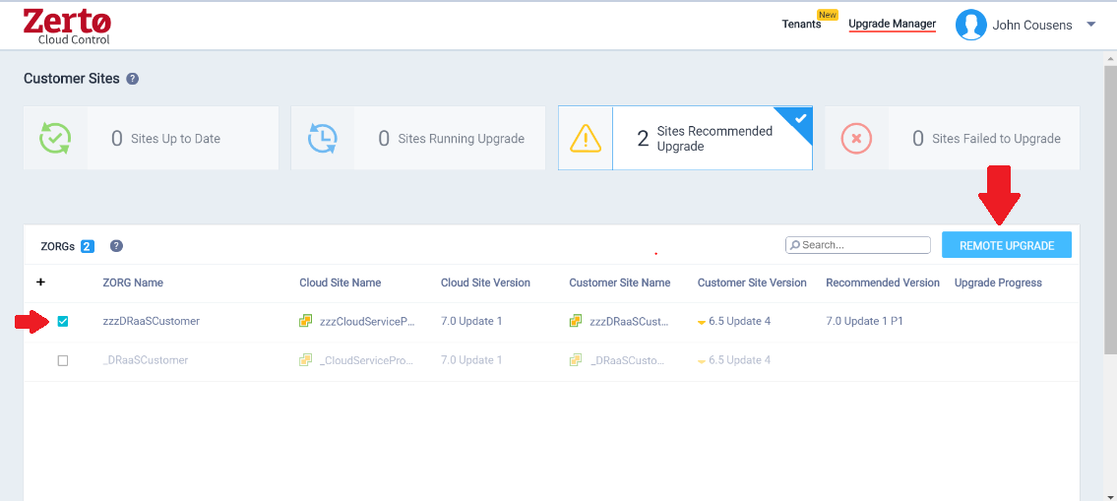

1. Once the Remote Upgrade option has been selected, a pop-up screen will appear to confirm the continuation of the request. This screen will also alert the user that the VRAs will be queued for upgrade once the ZVM finishes:

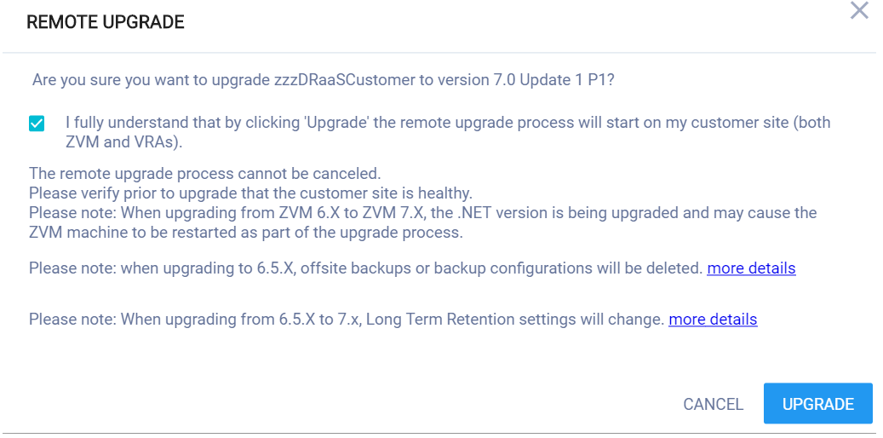

1. The remote ZVM will reach out to Zerto’s repository for the upgrade executable, download the files, and proceed with the upgrade on the ZVM. Once finished, the Upgrade Manager will alert the user with verbiage of its completion:

